**NYC MV Collision**

**Source to Target Mapping (S2T):**

**FCT_Collision_Crash-**

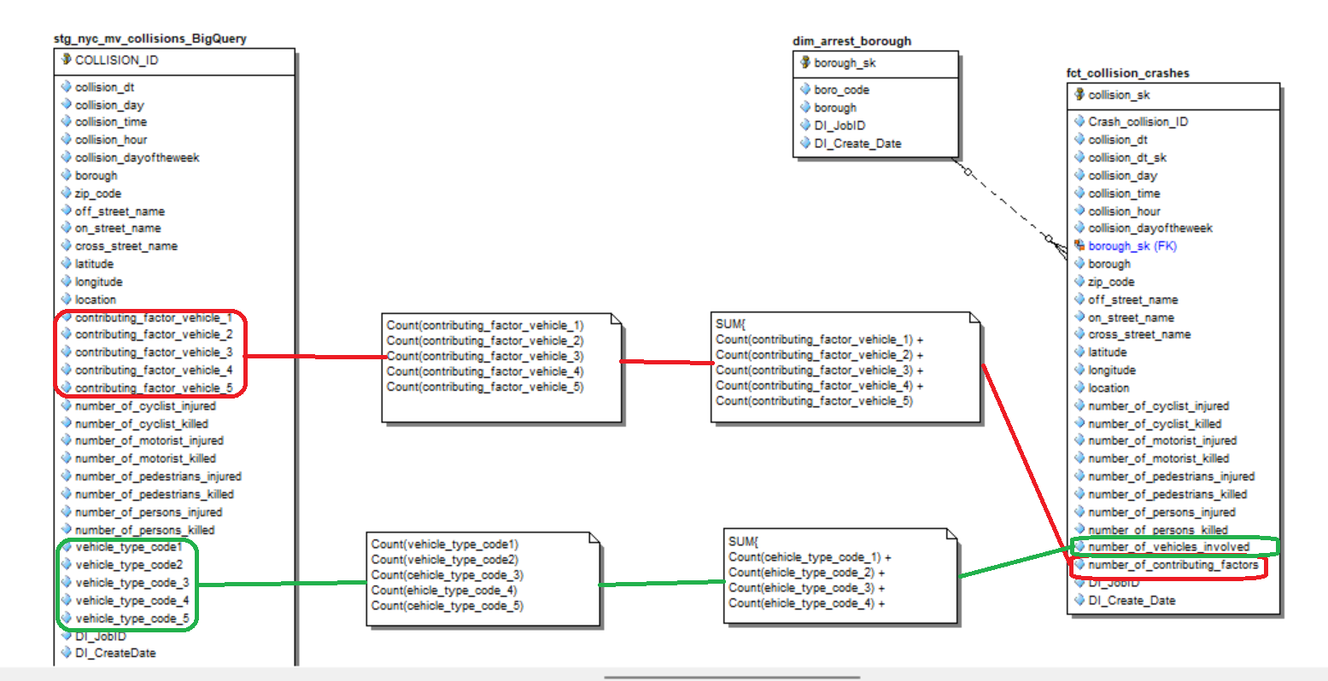

**FCT_Collision_Person-**

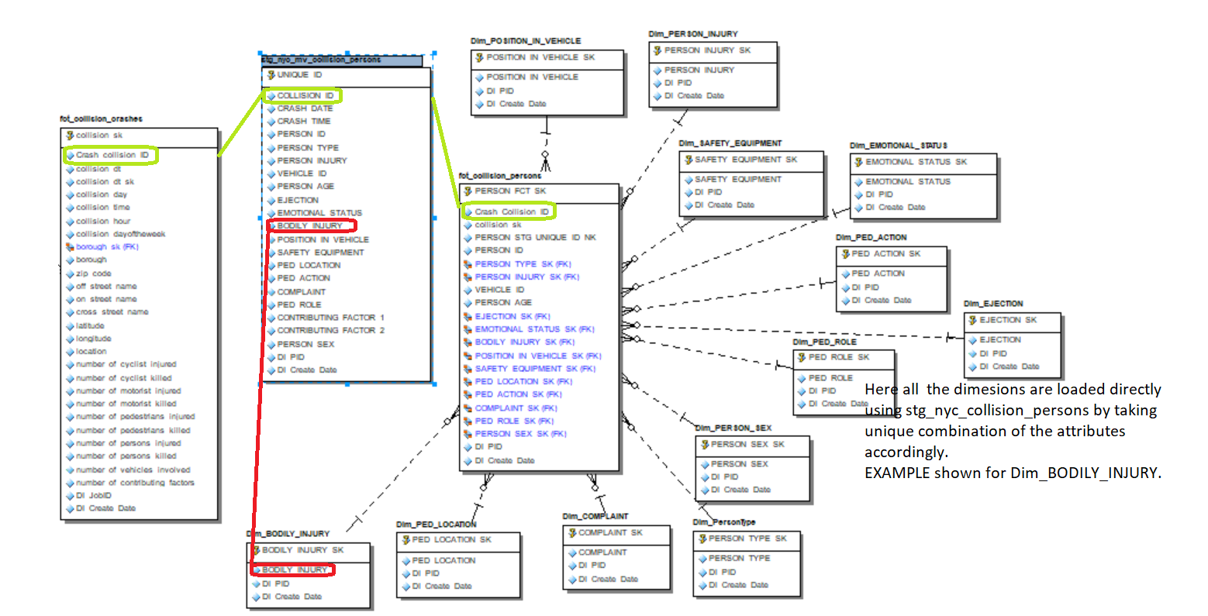

**FCT_Collision_Vehicle-**

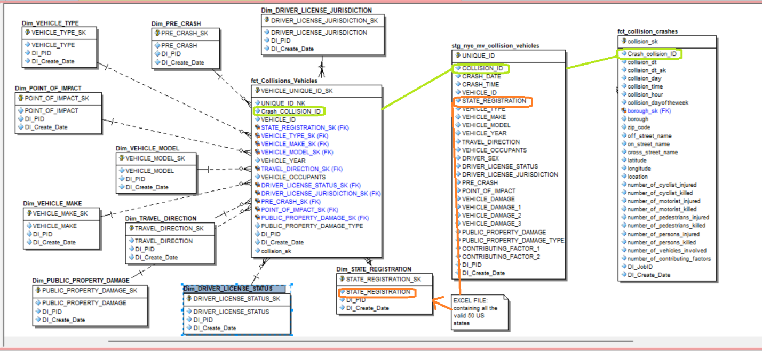

**Part 1: Alteryx Data Profiling**

STG_MV_Collision_Persons:

Job Time :

STG_MV_Collisions_Vehicles:

Job Time:

STG_ STG_MV_Collision_BigQuery

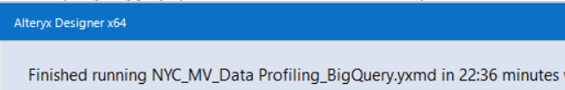

**Part 1: Talend Jobs for staging tables (along with Job Time)**

**Person Table:**

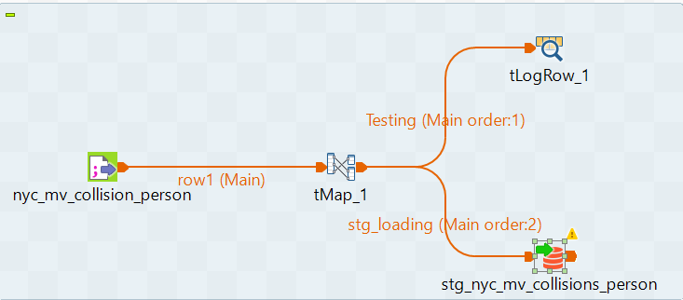

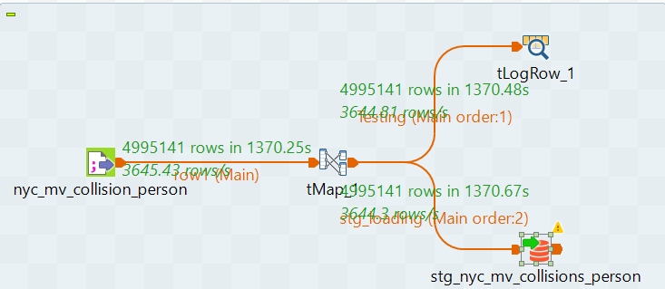

**BigQuery Collision Table:**

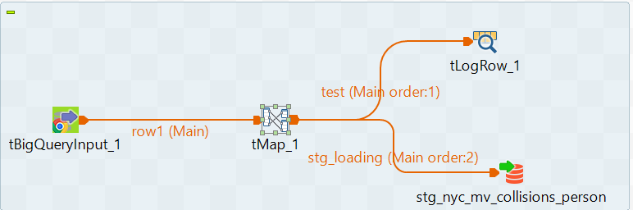

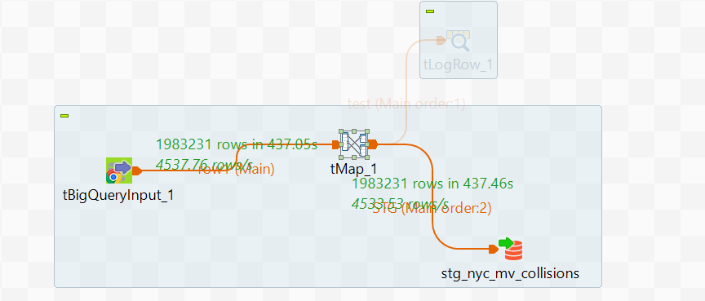

**Vehicle Table:**

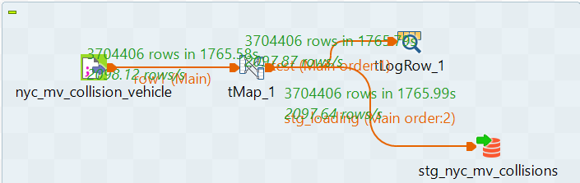

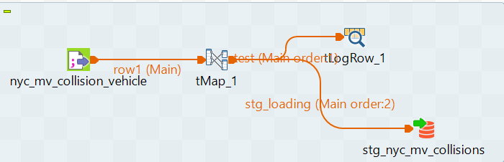

Stage Tables Count

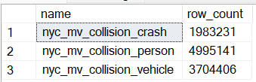

DImension Loading

Dim_NYC_BODILY_Injured

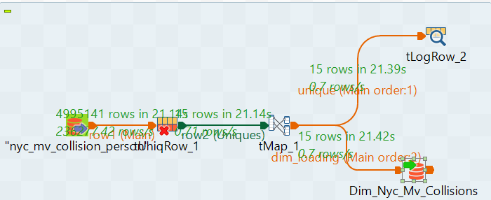

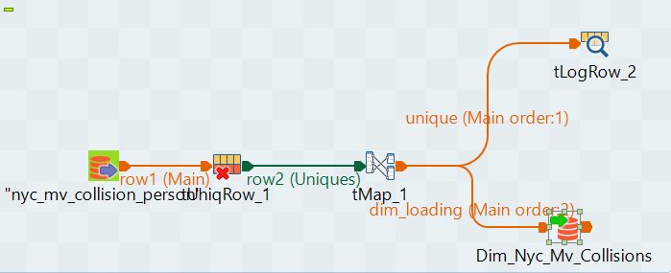

Dim_Complaint

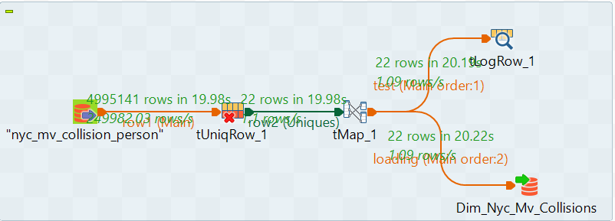

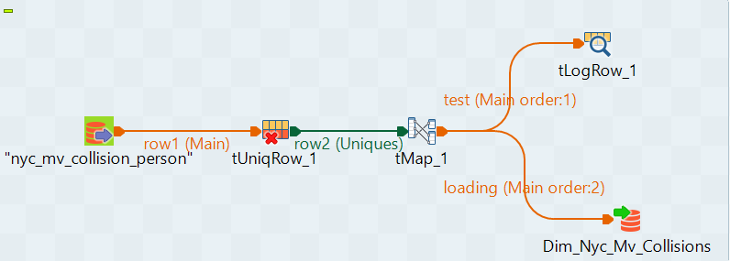

Dim_Borough

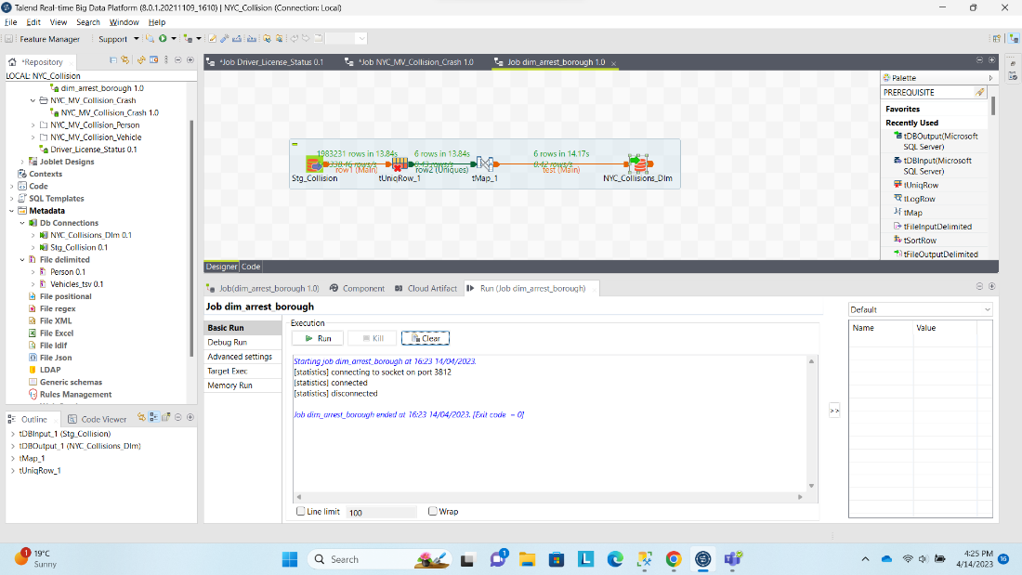

Dim_Ejection:

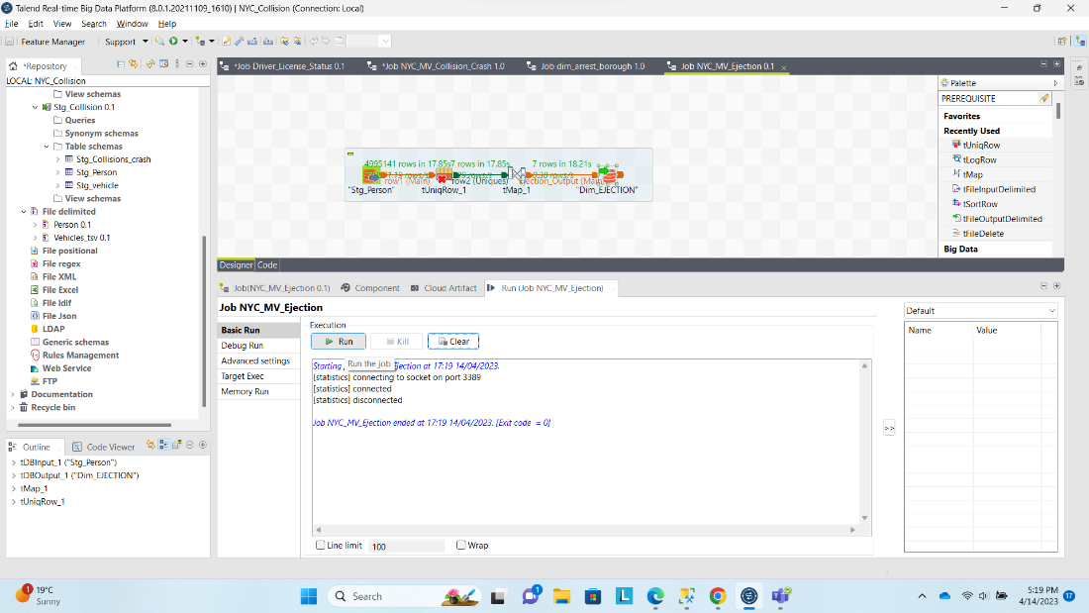

Dim_Ped_Action

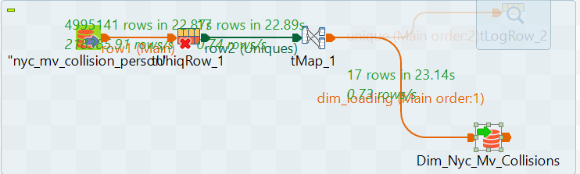

Dim Emotional Status:  
  
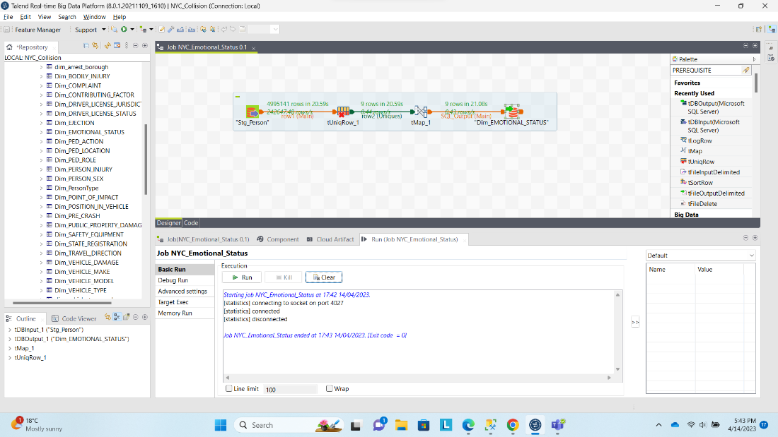

Dim_PED_LOCATION  
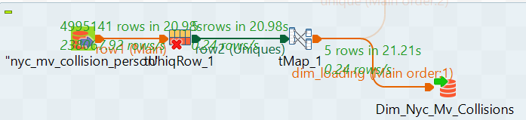

Dim_PED_ROLE

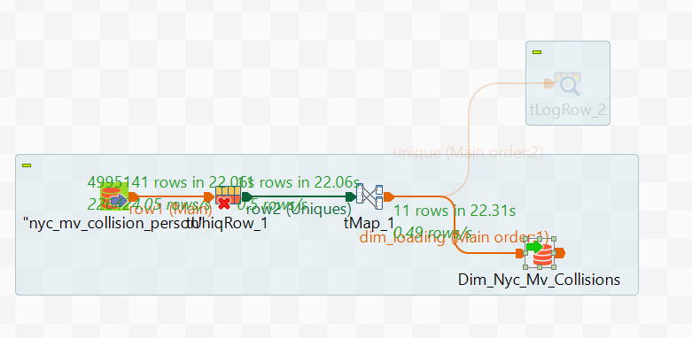

Dim_PERSON_INJURY

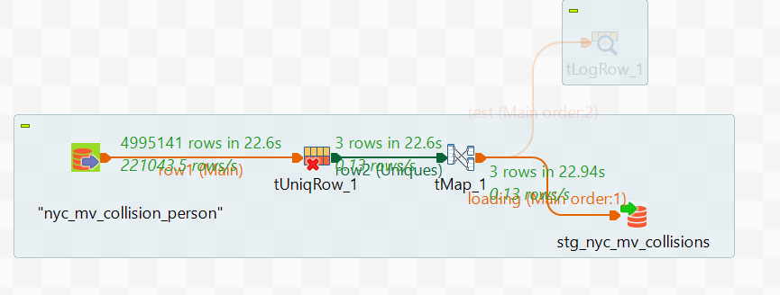

Dim Person Sex

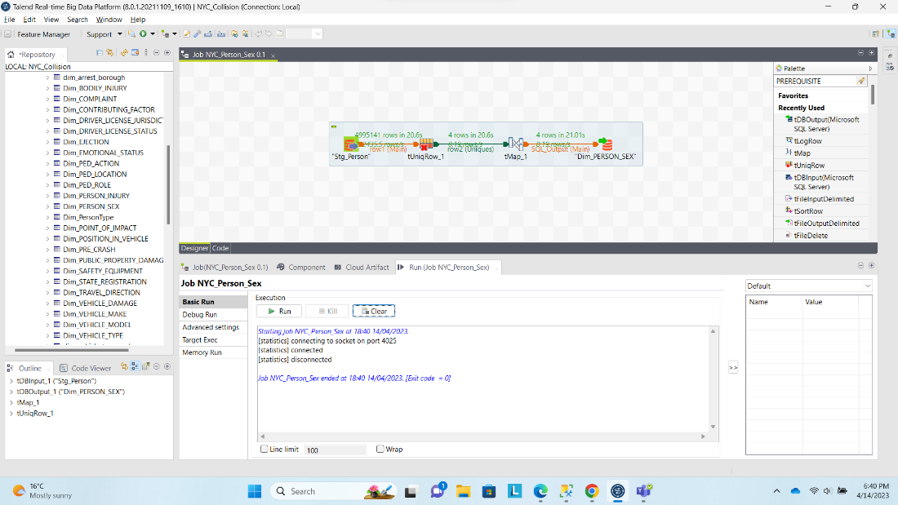

Dim_PERSON_Type

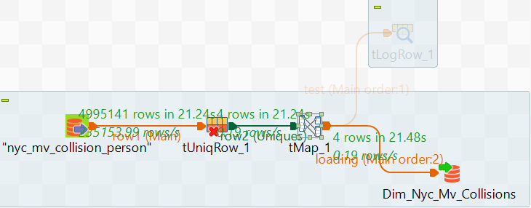

Dim_POINT_OF_IMPACT

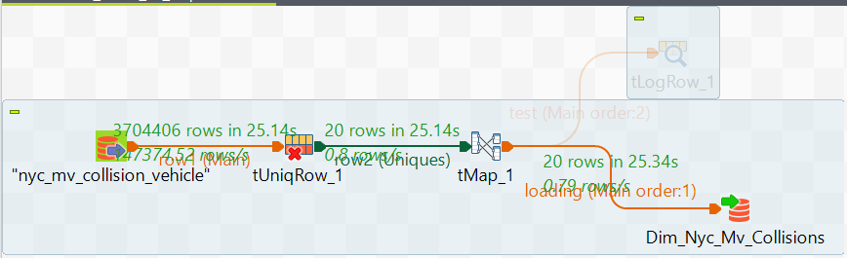

Dim_POSITION_IN_VEHICLE

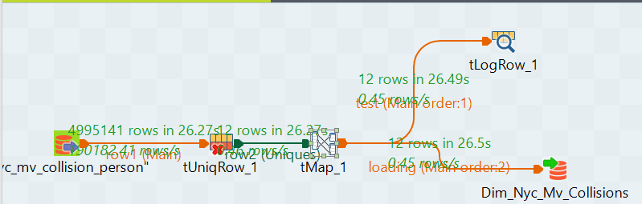

Dim_Public_property_Damage

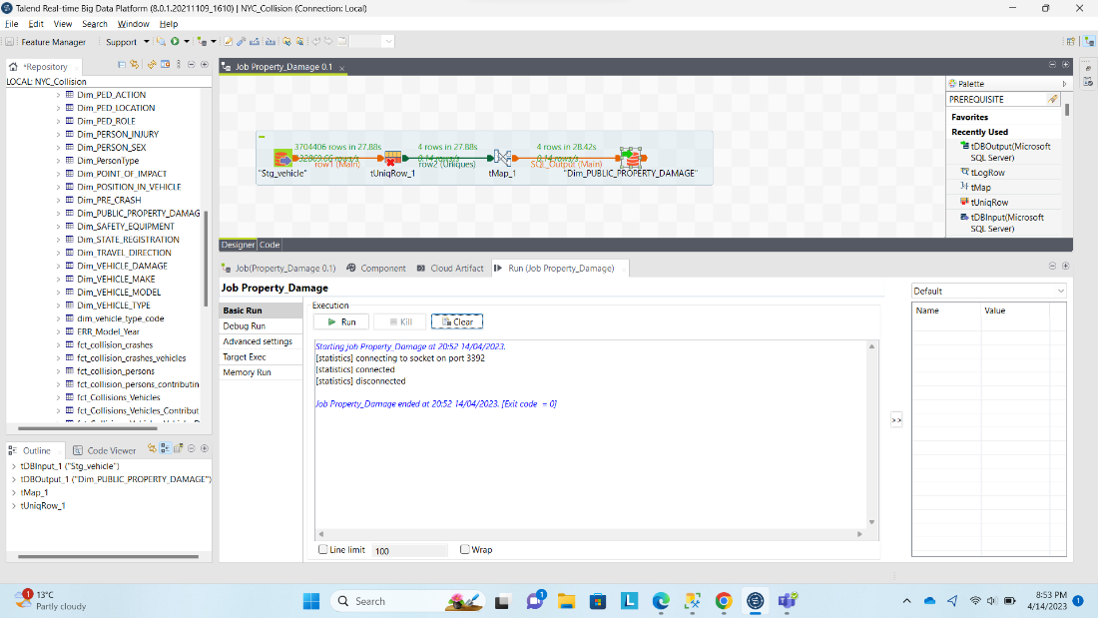

Dim_PRE_Crash

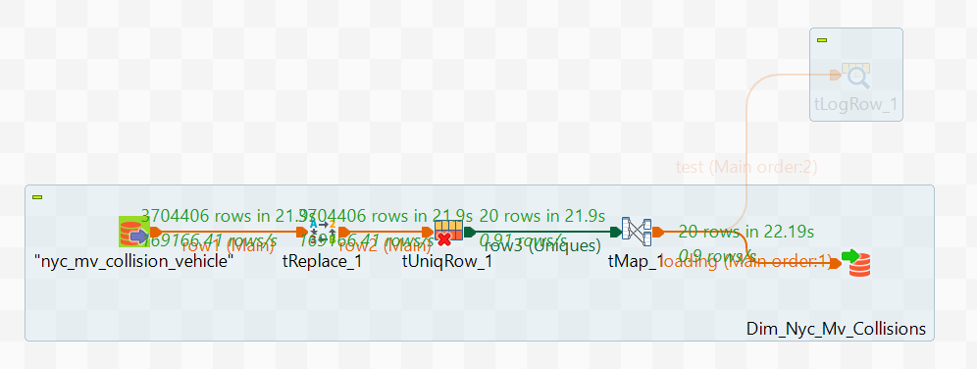

Dim Safety Equipment

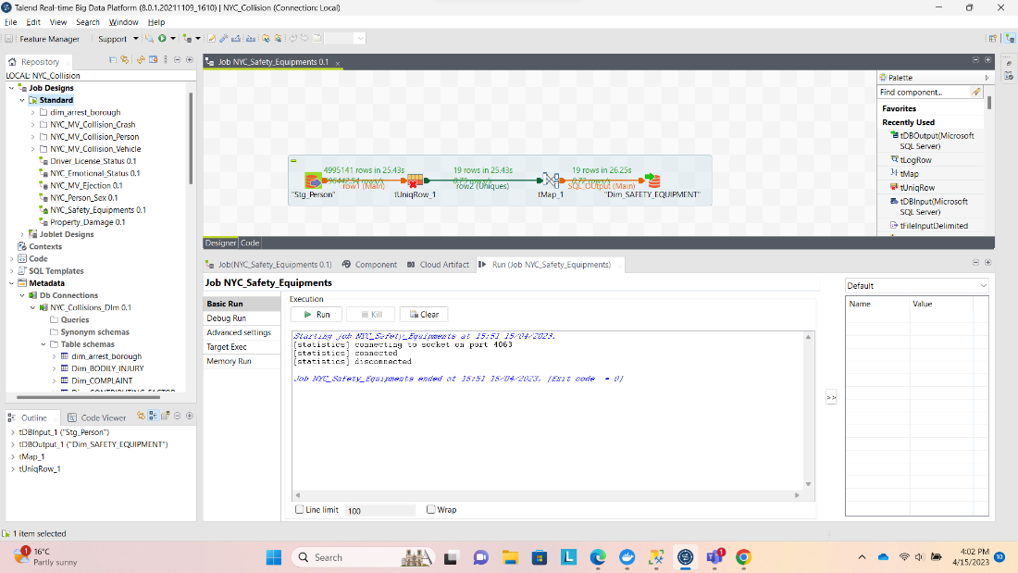

Dim Travel Direction

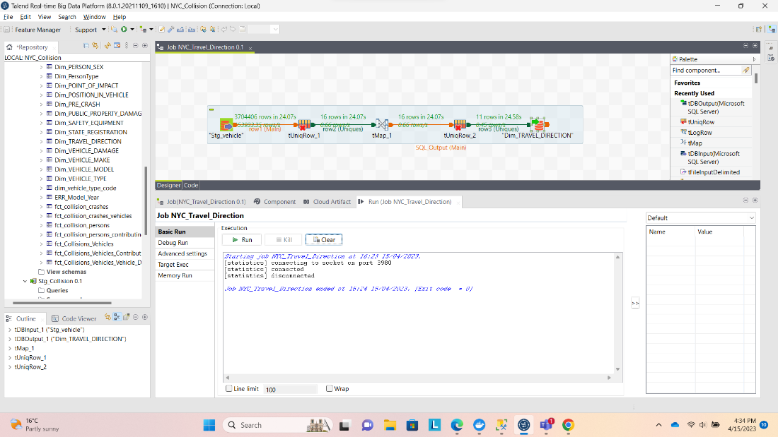

Dim Contributing Factor:  
  
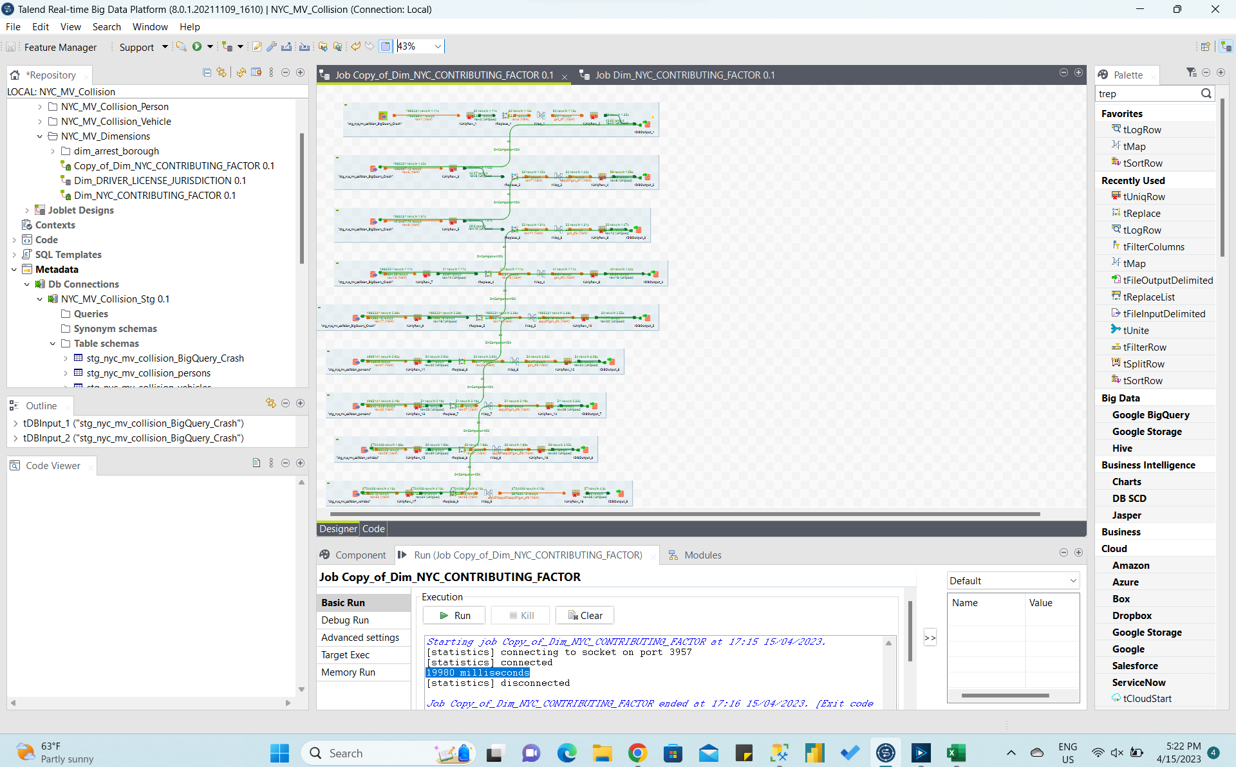

Dim Vehicle Damage

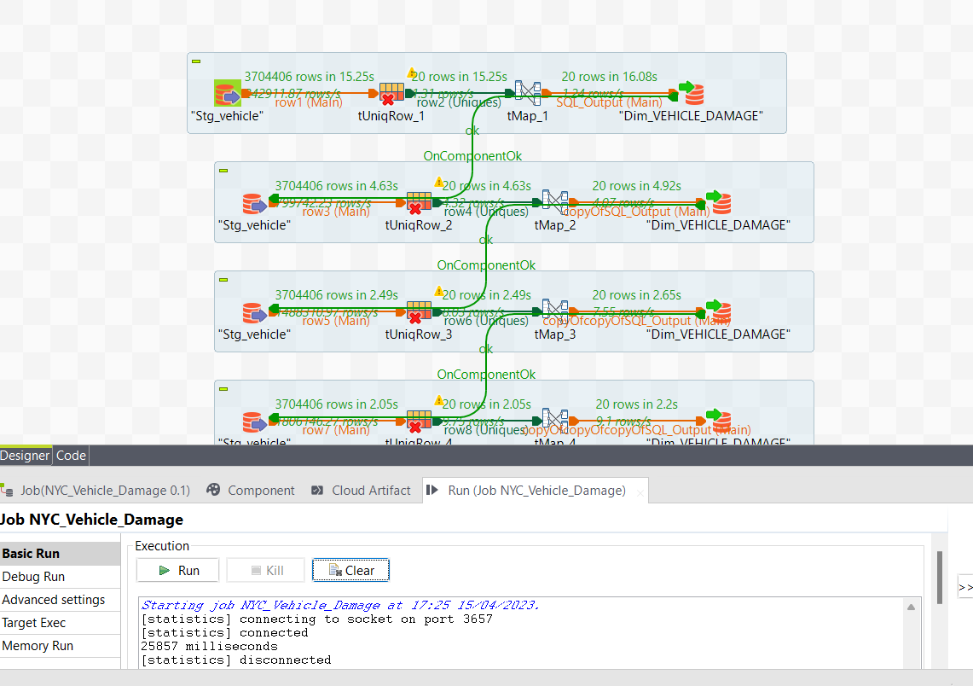

Dim_Driver_License_Jurisdiction:

Dim_STATE_REGISTRATION:

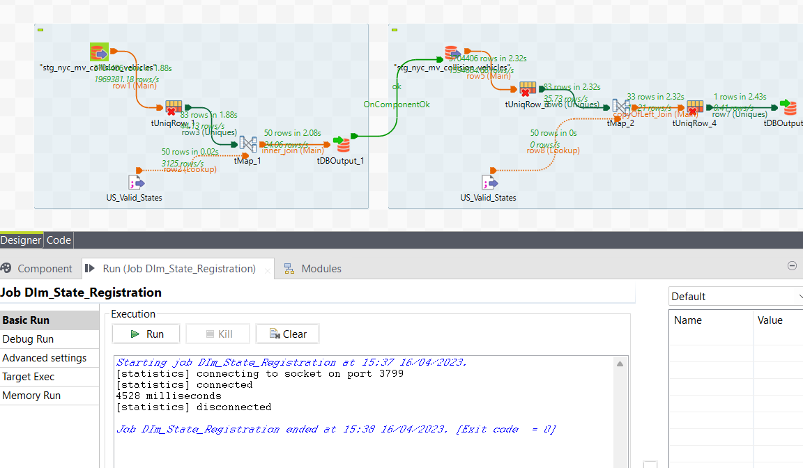

Dim_VEHICLE_MAKE:

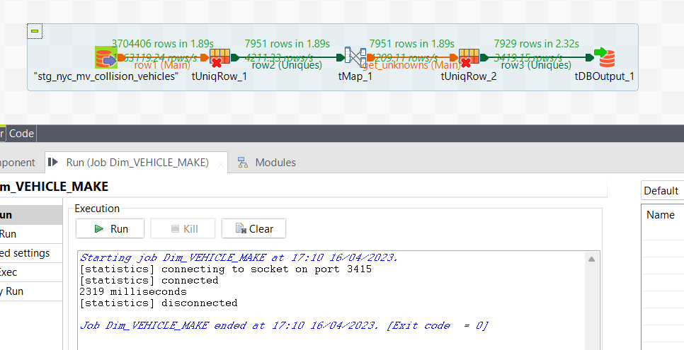

Dim Vehicle Type:

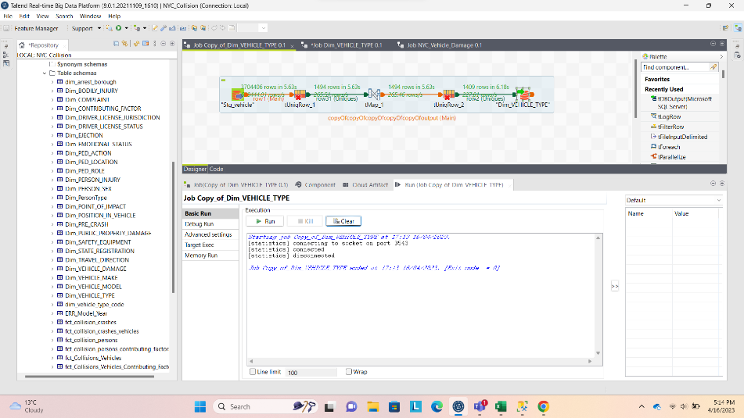

Dim_Vehicle_Model



Dim_Vehicle_Type_Code:

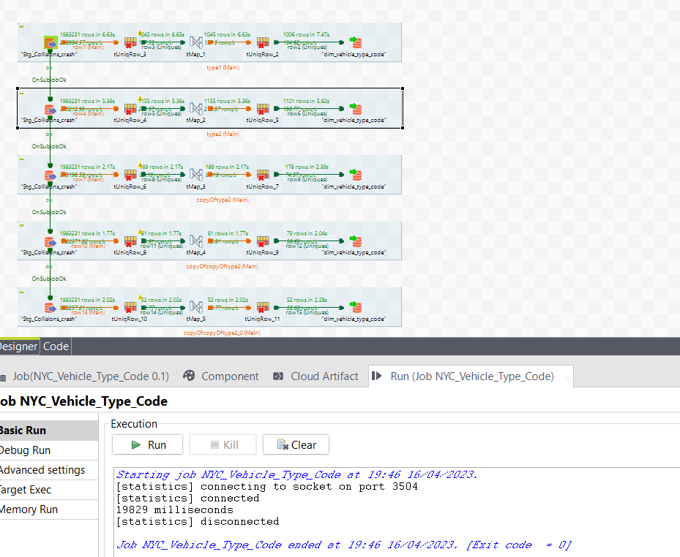

FCT_Collision_Crash:

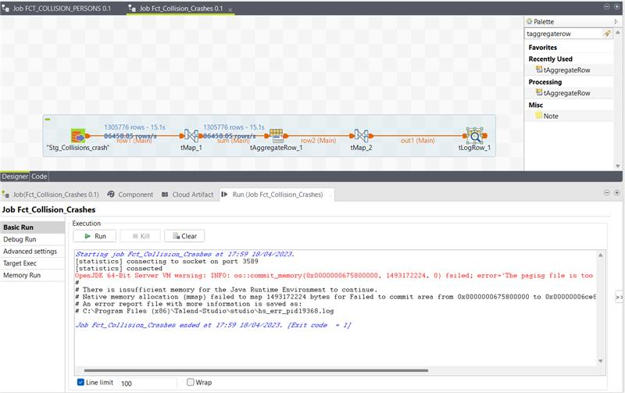

FCT_Collision_Person  
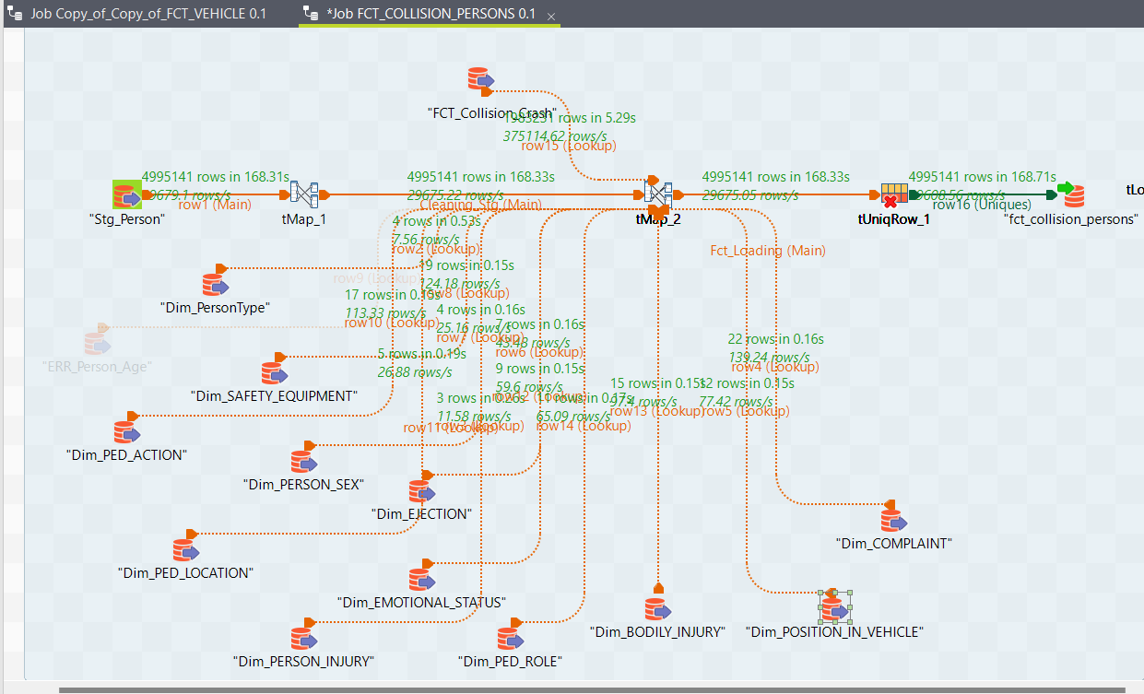

FCT_Collisions_Vehicles_Vehicle_Damage:

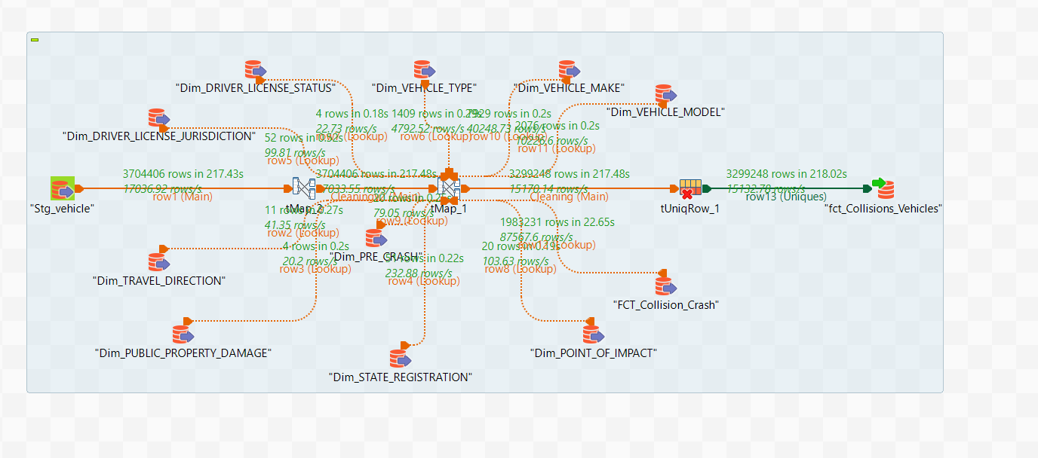

FCT_Collision_Crashes_Vehicles:

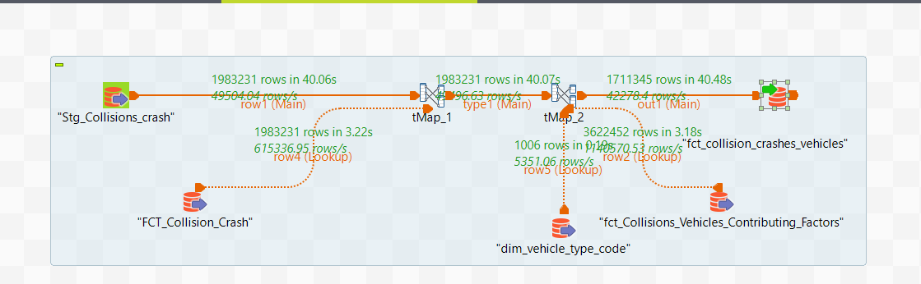

Master Job:

